Create a new ml file new layout Resource file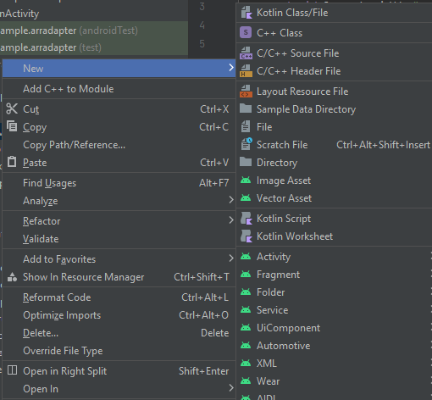

Activity main.xml

<?xml version="1.0" encoding="utf-8"?>

<RelativeLayout xmlns:android="http://schemas.android.com/apk/res/android"

xmlns:app="http://schemas.android.com/apk/res-auto"

xmlns:tools="http://schemas.android.com/tools"

android:layout_width="match_parent"

android:layout_height="match_parent"

android:orientation="vertical"

tools:context=".MainActivity">

<ListView

android:layout_width="match_parent"

android:layout_height="match_parent"

android:id="@+id/l1"

android:divider="#E91E63"

android:dividerHeight="2dp"/> />

</RelativeLayout>

Activity main.java

package com.example.arradapter;

import androidx.appcompat.app.AppCompatActivity;

import android.os.Bundle;

import android.view.View;

import android.widget.AdapterView;

import android.widget.ArrayAdapter;

import android.widget.ListView;

import android.widget.Toast;

public class MainActivity extends AppCompatActivity {

ListView mylistview;

String courselist[]={

"java",

"python",

"c++"

};

@Override

protected void onCreate(Bundle savedInstanceState) {

super.onCreate(savedInstanceState);

setContentView(R.layout.activity_main);

mylistview=(ListView) findViewById(R.id.l1);

ArrayAdapter<String> arrayAdapter =new ArrayAdapter<String>(this,R.layout.list,R.id.t1,courselist);

mylistview.setAdapter(arrayAdapter);

mylistview.setOnItemClickListener(new AdapterView.OnItemClickListener() {

@Override

public void onItemClick(AdapterView<?> adapterView, View view, int i, long l) {

String item=(String)mylistview.getItemAtPosition(i);

Toast.makeText(MainActivity.this, "Your selected course is "+item, Toast.LENGTH_SHORT).show();

}

});

}

}

List.xml

<?xml version="1.0" encoding="utf-8"?>

<LinearLayout xmlns:android="http://schemas.android.com/apk/res/android"

android:layout_width="match_parent"

android:orientation="vertical"

android:layout_height="match_parent">

<TextView

android:id="@+id/t1"

android:layout_width="wrap_content"

android:layout_height="wrap_content"

android:layout_weight="1"

android:text="TextView" />

</LinearLayout>

